**Results**

Minimum temperatures, freezing events, and growing degree days

Overall winter and spring temperature data show a gradual warming trend since 1980 at our study site but with absolute low temperatures not changing. We found that the mean low temperatures have been warming through the leaf-out period with February, March, and April warming on average of 0.05° to 0.08C per year for a total of roughly 2.2-3.5°C increase (p<0.001). The daily low temperature has warmed since 1980 (p<0.008), but the record low temperature for each year has not significantly increased since 1980 (p=0.243). Since 1980, the study site has seen fewer days with a low temperature below -2°C in the first four months of the year (Figure 1, p<0.0001, R2 = 0.343, slope = 0.525). Additionally, the Julian date for the last freeze event has advanced since 1980 (p=0.03, R2=0.09, slope= -0.388). Collectively, mean low temperatures have increased at our site and freezing events have become less common but low temperature extremes have stayed largely constant since 1980.

The accumulated growing degree days up to the final freezing event has not changed since 1980 despite documented changes in minimum temperatures (Supp figure; p>0.05). AGDD differed greatly in 2022 and 2023 with AGDD increasing faster in 2023 than 2022. Compared against the long-term average pattern of AGDD since 1980, 2023 was considerably advanced and 2022 was average and 2023 had one of the highest rates of spring warming of any year since 1980.

Against the backdrop of long-term temperature changes, the leaf-out period (defined as February to April) in 2022 and 2023 highlight strong interannual variation in winter and spring temperatures. In 2022 there were 41 days below -2°C, with 2023 having only 17 days that reached the same temperature threshold. However, the last freeze in 2022 was on 20 April, much later than the long-term mean of 24 March, while 2023 was slightly earlier than the long-term mean on 19 March.

Phenology

We found that the best selected model of AGDD at phenology stage 2 contained species and year as fixed effects. AGDD at stage 2 was higher for all species in 2023 than 2022 and Liriodendron tulipifera had lower AGDD at phenology stage 2 than Fagus grandifolia (Tukey HSD test, p = 0.005). No difference were found between A. saccharum and either of the other two species. Model results for phenology stage 3 were similar to stage 2 except the interaction between species and year was also included. This interaction was largely driven by a larger difference in AGDD between L. tulipifera and F. grandifolia in 2022 than in 2023. When modeling the julian date at phenology stage 2 and 3, we find that the best models contained species and year but no interaction between the two. At both stages, julian date was earlier in 2023 than 2022 and L. tulipifera reached the stage earlier than F. grandifolia

Notably, the National Phenological Network reported that in the southeastern United States, spring in 2023 was approximately 20 days ahead of 30-year leaf index dates (1991-2020, USA National Phenology Network 2023) in and around our study site. In comparison, the spring in 2022 was in-line or behind the 30-year index for the southeastern United States.

Thoughts on GDD – We can use growing degree days to show few things and deal with the reviewers who focus on phenology. At our site, 2023 was obviously warmer than average, we find this whether we look at GDD or just mean temperature. We also see that the GDD before the date of the last freeze hasn’t changed since 1980. This means that the amount of warmth trees experience before the last freeze doesn’t seem to increase or decrease through time. If it had increased, then that would suggest phenology could be advancing (because it is forced through GDD) while late spring frost hasn’t changed.

Alternative

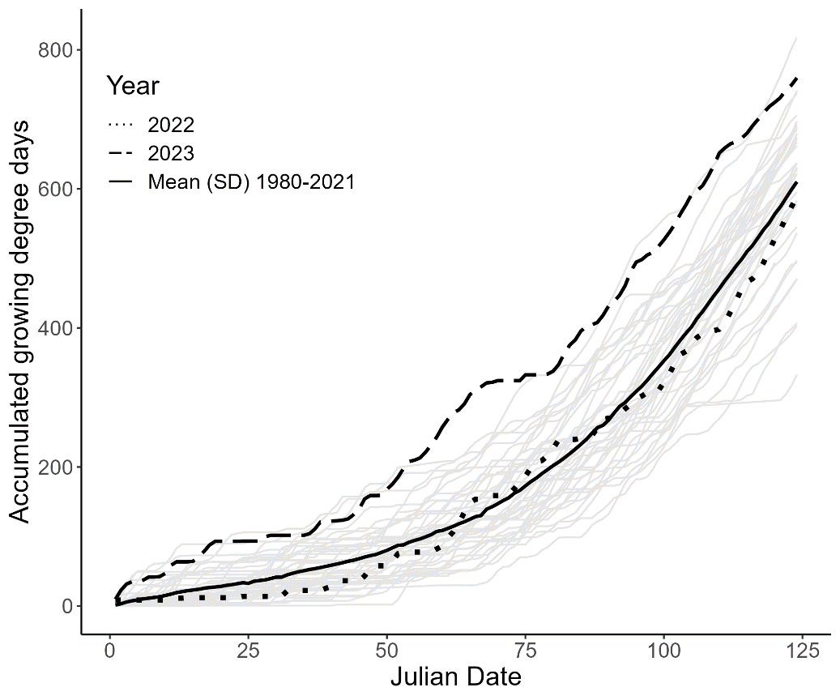

New Figure X: Accumulated growing degree days since January 1st for study years (2022 – dotted, 2023 – dashed) and long-term average from 1980-2021 (solid lines with SD[gray shaded area). 2023 being warmer than 2022 and long-term average. 2022 being a pretty average year.

Supplementary figure X: Accumulated growing degree days up until the last freezing date since 1980. For each year I found the last day with a 0C temperature and then calculated GDD up until that date.



GDD (top row) and Julian Day (bottom row) for phenophases 2 and 3 for each species in each sample year.

The best model to explain variation in LT50 included year, phenology stage and species but did not include any interactions. We found that *A. saccharum* had less negative LT50 values than *F.* *grandifolia* (p=0.002, Tukey HSD test, Table 3) and *L.* *tulipifera* (p<0.001), but no difference was found between *F.* *grandifolia* and *L.* *tulipifera*. We also found that phenology stages 0 and 1 had more negative LT50 values than the other stages (all comparisons p<0.05, Tukey HSD test, Table X) and that stages 2, 3 and 4 did not differ from each other. Finally, we found that freezing tolerances were more negative in 2023 than in 2022, despite advanced phenology and an overall warmer winter and spring in 2023.

Figure X: Freezing tolerance (LT50) at each phenology stage for both sampling years and all species.

NEED TO ADD IN THERMAL SAFETY MARGIN